**2-1 Assignment: CRUD in MongoDB**

Winnie Kwong

Southern New Hampshire University

CS-340-H7049 Client/Server Development

Professor Paruchuri

November 4th, 2023

**Screenshots**

**Database Creation (Part A)**

**Database Creation (Part B)**

**Data Insertion**

**MongoDB Queries**

1. What is the distinct list of inspections “sector” in the current inspections collection? How many are on the list? Do not count by hand.

There are 87 “sectors” in the current inspections collection.

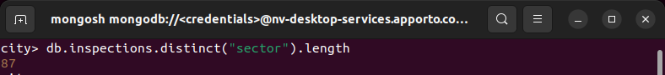

1. What is the difference in the date data type for the business named “AUSTIN 2012” versus your business document insertion of “Acme Explosives”?

The difference is the format issue between both business names. The AUSTIN 2012 does not include the time whereas the acme explosives does.

1. How many businesses have a “Violation Issued”? (See Value column above.)

There are 13823 businesses that have a violation issue.

**Update Document**

**Update Subdocument**

**Remove Document**

